Database Design Document

Submitted By:

- Ahd Montaser Jamea

Abstract:

This project presents a database design for a ride-hailing system that helps users choose the best company based on trip price and estimated time.
The system allows users to compare different companies using trip details such as cost and duration.

The database was designed according to software engineering principles.
Python was used only to generate fake data and create static SQL files for testing purposes.

The database serves as a data storage layer accessed through backend APIs.
CHAPTER 1
INTRODUCTION

This chapter gives an overview of the aim, objectives, background and operation environment of the system:

PROJECT AIMS AND OBJECTIVES:

- Design a structured database for ride-hailing services.
- Store trip price and estimated time data.
- Support comparison between different companies.
- Ensure data accuracy and consistency.
- Improve user decision-making.
- Support future integration with backend APIs

Detailed Database Design:
2.Company
Primary key: company_id

Attributes:
- Company_name

4.Trips
- Primary key: trip_id

Attributes:
- Pickup
- Dropoff
- Distance_km
- Time_min
- Price

1.User
- Primary key: user_id

Attributes:
- Name
- Email
- Password
- Phone

3.Drivers
- Primary key: driver_id

Attributes:
- Driver_name
- Car_model
- Phone

In a well-organized GoCheap database, every table has a unique way to identify its records using primary keys and establishes relationships between tables through foreign keys.

The User table stores all registered users, uniquely identified by <user_id> as the primary key. Each user can make bookings or transactions, so <user_id> acts as a foreign key in the Trips table to link actions to the correct user.

The Company table stores all transport companies, uniquely identified by <company_id> as the primary key. Each company can have multiple drivers and trips, so <company_id> acts as a foreign key in the *Driver* and *Trip* tables.

The Driver table stores all drivers working for companies, uniquely identified by <driver_id>as the primary key. Each driver belongs to a company, so <company_id> acts as a foreign key linking drivers to their company in the Company table.

The Trip table stores all available trips, uniquely identified by <trip_id> as the primary key. Each trip is offered by a specific company and assigned to a specific driver, so <company_id> and <driver_id> act as foreign keys referencing the Company and Driver tables.

Relationships:

- Trip ↔ User
Relationship: Request
Type: One-to-Many (1:M)
Description: A user can request multiple trips, but each trip is requested by only one user.

- Trip ↔ Driver
Relationship: Drives
Type: One-to-Many (1:M)
Description: A driver can drive multiple trips, but each trip is driven by only one driver.

- Company ↔ Driver
Relationship: Work_in
Type: One-to-Many (1:M)
Description: A company can employ multiple drivers, but each driver works in only one company.

- Company ↔ Trip
Relationship: Owns
Type: One-to-Many (1:M)
Description: A company can own multiple trips, but each trip belongs to only one company.

- BACKGROUND OF PROJECT:

PROCESSOR | Intel(R) Core(TM) i7-6700HQ CPU @ 2.60GHz
OPERATING  SYSTEM | Windows 10 Pro
MEMORY | 32GB DDR5 8400MHZ
HARD DISK SPACE | 0.5TB m.2 NVMe Gen6
DATABASE | MSQL Server
Website of Diagrams | Draw.io & Access

CHAPTER 2
Database Design

- Database Schema:

Figure 1: Schema diagram for GO Cheap:

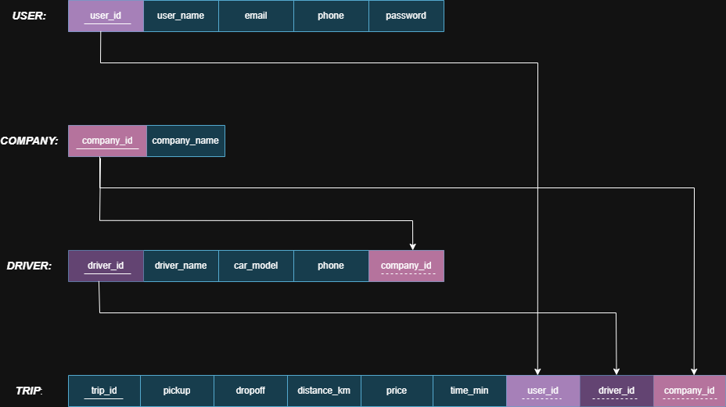

Figure 2: Relational diagram for GO Cheap:

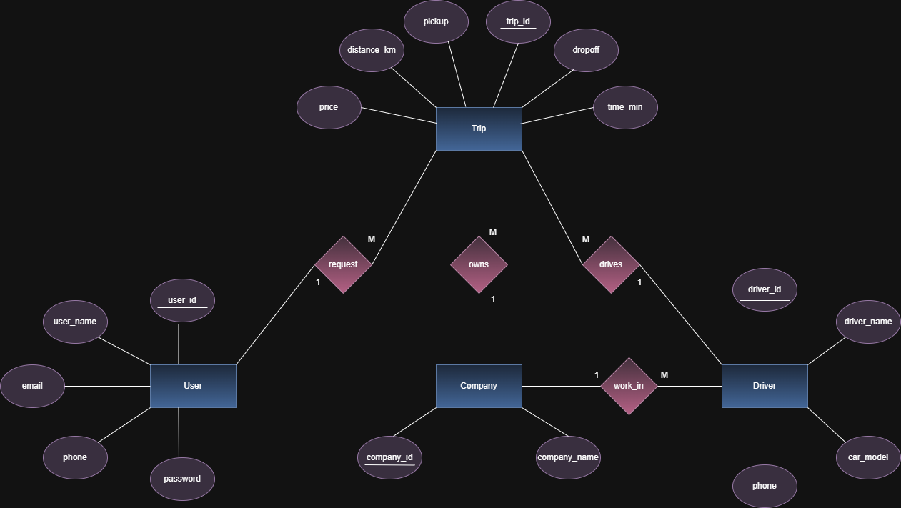

2.TABLE DESIGN:
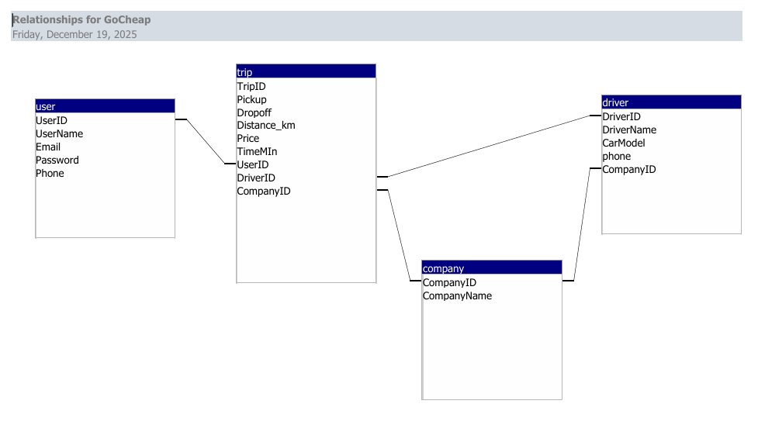

CHAPTER 3

REFERENCES

* Uber – https://uber.com
* InDrive – https://indrive.com
* DiDi – https://web.didiglobal.com
* ChatGPT – https://chat.openai.com

